**Assignment 1: Connect to a Specific Subscription using PowerShell**

**Objective: Learn how to connect to a particular Azure subscription using PowerShell.**

Use PowerShell to connect to a specific Azure subscription.

Display the details of the subscription to confirm the successful connection.

Commands:

Get-AzureSubscription: this will give you the list of subscription

Select-AzureRmSubscription -SubscriptionId “f3assd” : this way you can set which particular subscription you want to use

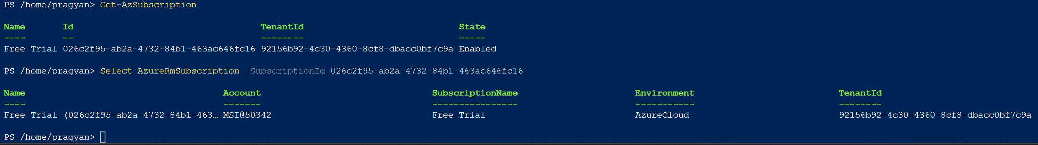

**Assignment 2: Create a Resource Group using PowerShell**

**Objective: Practice creating an Azure Resource Group using PowerShell.**

Write a PowerShell script to create a new Azure Resource Group.

Choose an appropriate name and location for the resource group.

Command : New-AzResourceGroup RG01 "Central India"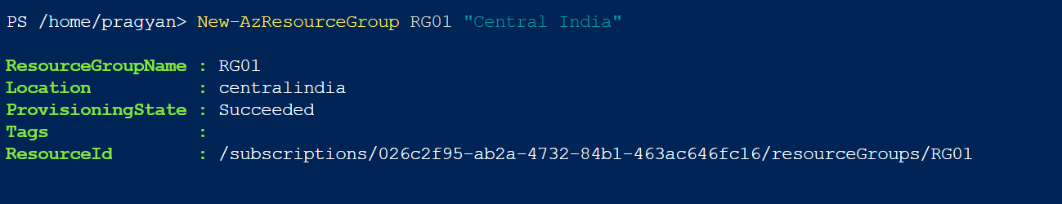

Confirm the creation of the resource group using the Azure portal.

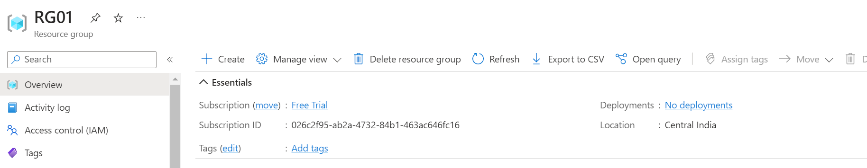

**Assignment 3: Create a Virtual Network and Subnet using PowerShell**

**Objective: Understand how to create a virtual network and subnet in Azure using PowerShell.**

Write a PowerShell script to create a virtual network.

Command : New-AzVirtualNetwork -Name 'MyVirtualNetwork' -ResourceGroupName RG01 -Location "Central India" -AddressPrefix '10.0.0.0/16

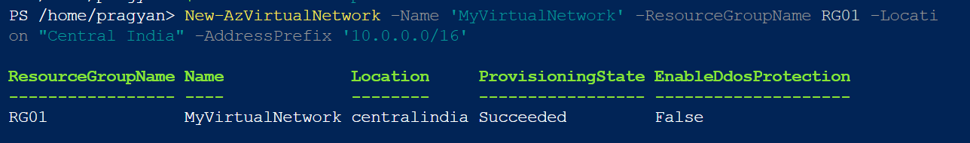

Include a subnet within the virtual network

Command : Get-AzVirtualNetwork -Name 'MyVirtualNetwork' -ResourceGroupName RG01

Verify the creation of the virtual network and subnet in the Azure portal.

